EventPlanLine Table (I m using Oracle and Sql Developer Client)
- CREATE TABLE Statement
CREATE TABLE EventPlanLine
(
PlanNo varchar2(8) CONSTRAINT PlanNumberabsent not null ,
Lineno char(1) CONSTRAINT LineNumberabsent not null,
Timestart date CONSTRAINT Timestartabsent not null,
Timeend date CONSTRAINT Timeendabsent not null,
Numberfld char(1) CONSTRAINT Numberfldabsent not null,
LocNo varchar2(8) CONSTRAINT LocNumberabsent not null,
ResNo varchar2(8) CONSTRAINT ResNumberabsent not null,

CONSTRAINT EventplanlinePK PRIMARY KEY(PlanNo,LineNo),
CONSTRAINT planoFK FOREIGN KEY(PlanNo) REFERENCES Eventplan,
CONSTRAINT locnoFK FOREIGN KEY(LocNo) REFERENCES Location,
CONSTRAINT resnoFK FOREIGN KEY(ResNo) REFERENCES ResourceTbl,
CONSTRAINT ChorologicalCheck CHECK (Timestart < Timeend)
);

- Run the above command
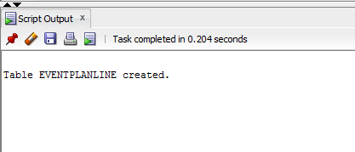
- Insert rows into it

Using Sample insert statements given in the assignment
- Table data
